**OUTPUT**

Case 1: 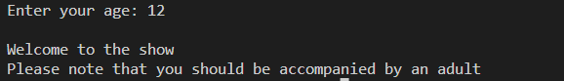

Case 2:



Case 3:



Case 4: 